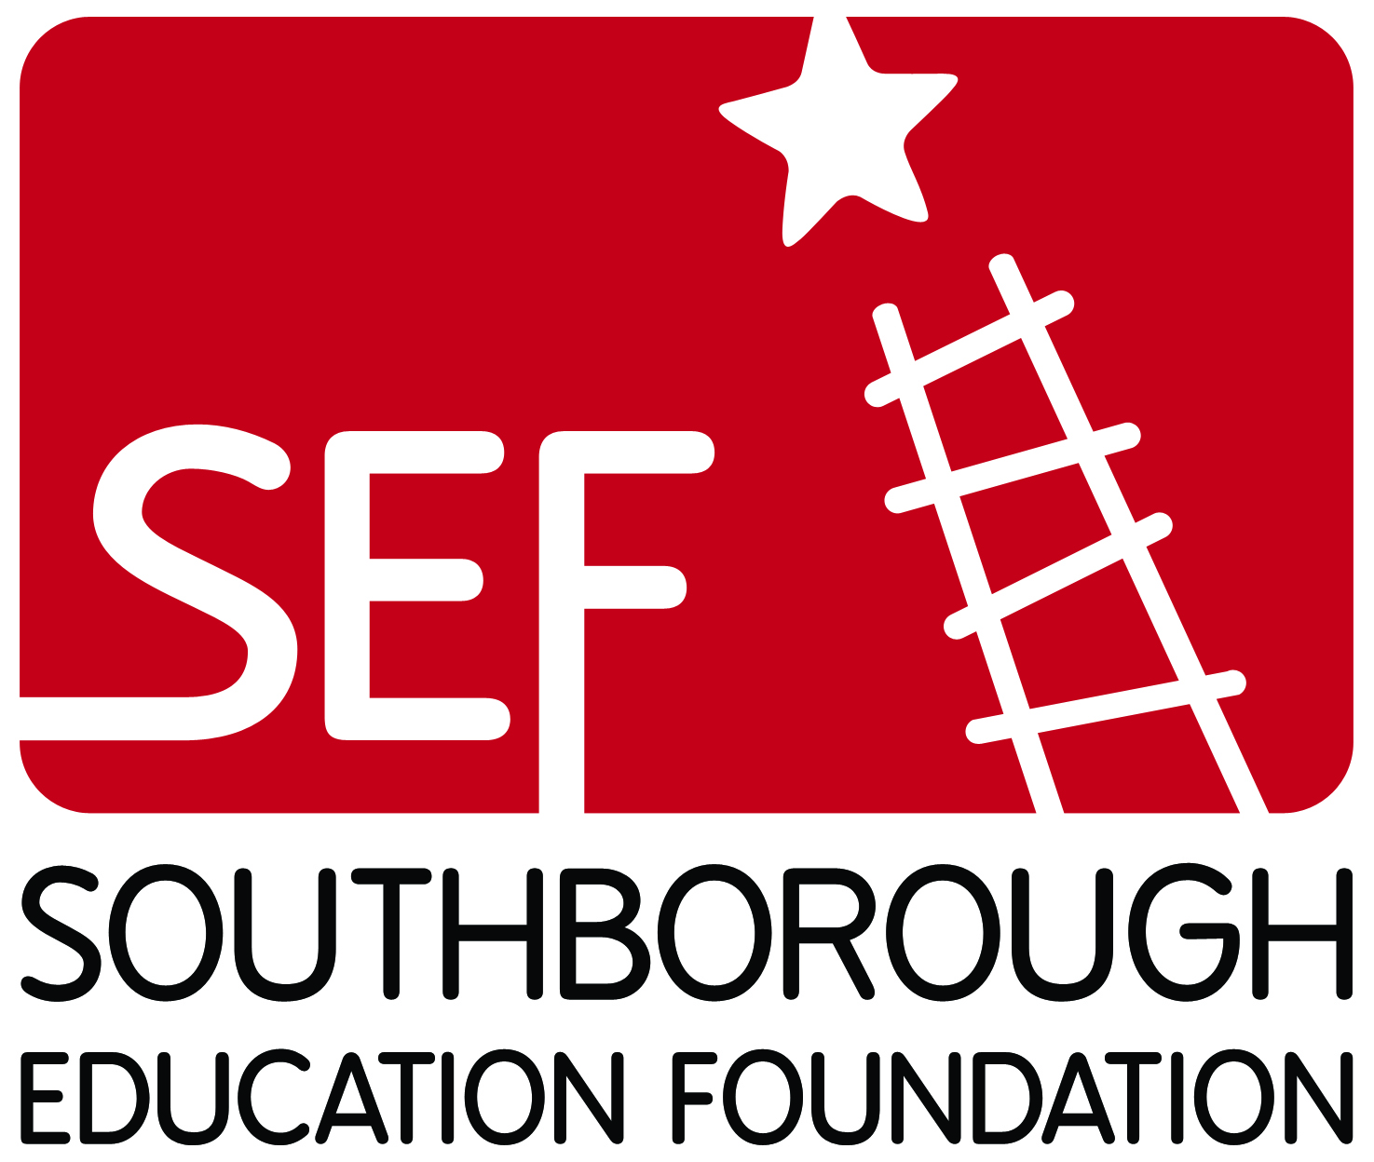 | Family Feud Sponsor Form  All proceeds to benefit the students and teachers of the Southborough Public Schools  March 15th, 2019 ~ Trottier Middle School  Doors Open: 5:30 p.m. ~ Show Begins: 6:30 p.m.
Print this page, then complete and return the form to, Southborough Education Foundation (SEF), P.O. Box 365, Southborough, MA 01772. Make checks payable to the Southborough Education Foundation. All contributions to SEF are tax deductible. For more information, e-mail SEF at southboroughedfoundation@gmail.com. Please include "Family Feud" in the subject line of your email.
Sponsor name:____________________________________________________________________________
(as you would like it to appear in print)
Contact Person:___________________________________________________________________
Phone:___________________________________________________________________________
Address:_________________________________________________________________________
Email:_____________________________ Preferred method of contact? ____email ______phone
______Full page ad in the Program Book plus team sponsor ______ $500.*
______Sponsor ______ rounds(s) at $400 per round.
______Sponsor______ question (s) at $100 per question (question/s determined by SEF).
______1/2 page ad in the Program Book ______ $250 per ad.*
______1/2 page ad in the Program Book plus team sponsor ______ $400.*
______We would like to make a donation of $ ______ to generally support the SEF Family Feud.
*An SEF Board Member will contact you for any Program Advertisement artwork needed. Please complete and mail the form above, or complete your sponsorship online via Paypal at: http://www.southboroughed.org/#!events/cfvg

