Media Contact: Brandi Griffin  Foundation for MetroWest  bgriffin@foundationformetrowest.org  Phone: (404) 989-1825 | 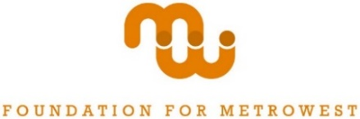 | 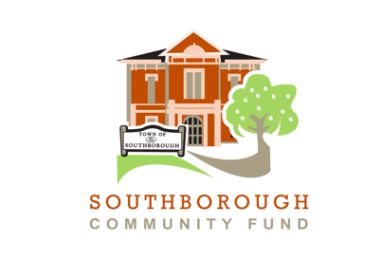

Southborough Community Fund and Southborough Education Foundation Officially Unite

Red Apple Award campaign to kick off this week as first official initiative as merged funds.
May 13, 2021 (Natick, MA) – The Southborough Community Fund (SCF), a town fund of the Foundation for MetroWest, is proud to announce that the MA Attorney General’s office has officially approved the organization’s proposed merger with the Southborough Education Foundation (SEF).
Since 2014, SCF has been a source of funding to support community needs and opportunities in the areas of Human Services, Arts & Culture, Environment, and Community Building, and has provided ways for residents to make an immediate impact in their community. Historically, SCF has not included Education in its funding initiatives, but the unification with SEF has allowed the Fund to broaden resources and expand its reach of issues.
“Over the seven years of our existence the Southborough Community Fund has already raised and deployed over $475,000, becoming a critical resource for meeting growing needs in our community,” said Tom Crotty, Chair of the Southborough Community Fund. “We are excited for the opportunity to combine resources with SEF and provide incremental financial support for initiatives that are important to Southborough residents.”
As the first initiative as united funds, the Southborough Community Fund will kick off the Red Apples Award, a campaign that is historically significant to the Southborough Educational Foundation. The Red Apples Award program enables supporters to show their appreciation for a child’s special teacher or staff member. All donations made via the Red Apples award program will continue to support innovative educational programs for children in Southborough.
"Throughout this unique and challenging year, our educators and administrators have worked tirelessly to ensure high quality learning experiences for our children, whether in the classroom or on Zoom," said Erin Cox, SCF Board member. "By participating in the Red Apples program, families can honor our amazing educators and strengthen SCF's future educational grant-making efforts. It's a win/win," she said.
The Southborough Community Fund and Southborough Education Foundation are grateful for the community’s support during this transition. For more information on the Red Apples Award, visit https://bit.ly/RedApple2020
About the SCF and SEF Uniting
Combined under the SCF banner, fundraising initiatives employed by both organizations will continue including through various town fund raisers such as Red Apple and an annual town appeal mailing at year end. Due to the ongoing Covid-19 pandemic and the limitations on in-person events, the fund encourages donating through the website: https://foundationmw.org/give/town-funds/southborough-community-fund/

